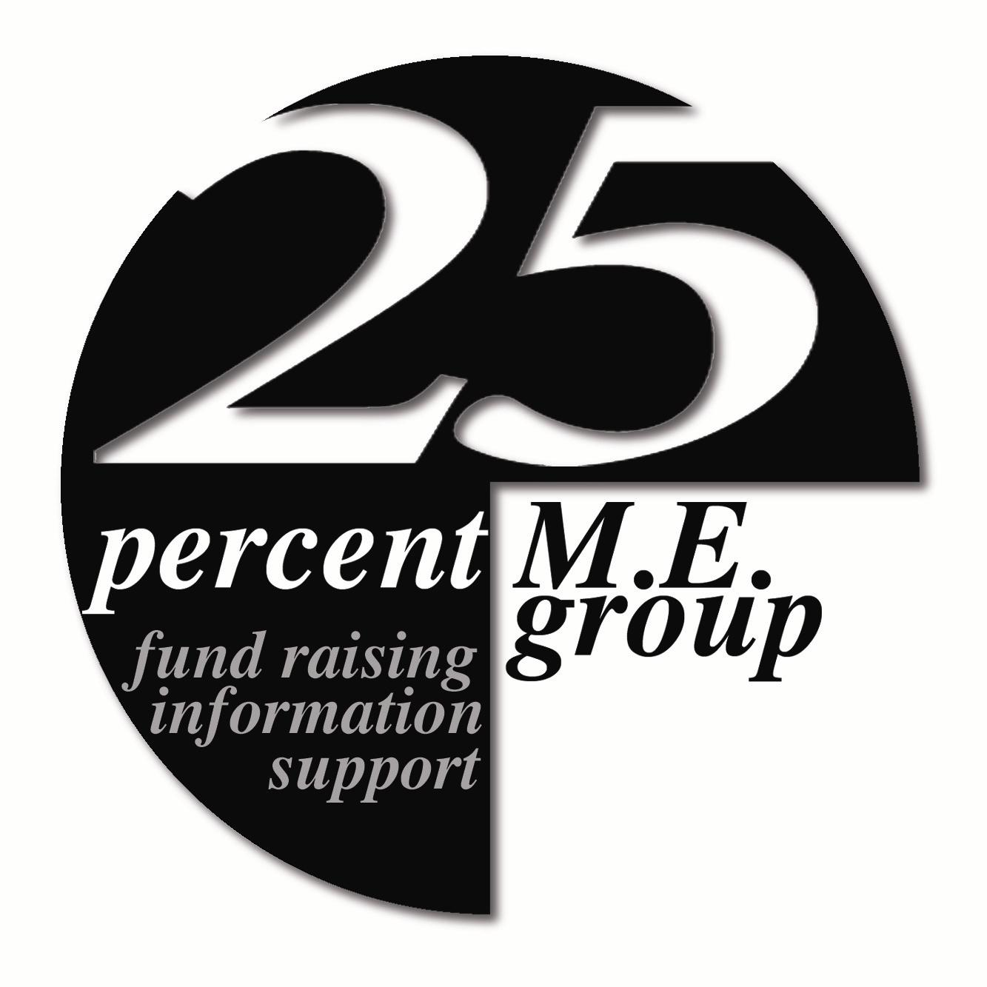
ME Awareness Campaign 2017

About the pro forma letter to NHS England
      - The ‘MUPS’ publication relates to England only. If you live elsewhere in the UK it does not apply. We therefore advise that only members living in England send the letter.
      - Please remember to put your address on the letter for reply.
      - Letters can be more effective if they are personalised. You may wish to say something about your own situation / experience - particularly if you have already experienced medical neglect, or inappropriate attitudes or management due to your illness being viewed as a mental or behavioural disorder.
      - We will place this item at the ME Awareness 2017 section of the 25% ME Group website so that if you have web access, you can download a copy to edit.

About the Joint Commissioning Panel for Mental Health (JCP-MH) www.jcpmh.info
The JCP-MH came into being in 2011, and (ostensibly) publishes guides to what a good service should look like. Their scope is mental health and learning disability.
- The JCP-MH describes itself as ‘a collaboration between leading organisations’ and lists a wide variety - including several medical Royal Colleges, the Department of Health, representatives of the English Strategic Health Authorities, several mental health charities and support organisations, and ‘service users and carers’.
- It is jointly chaired by a representative of the Royal College of Psychiatrists (currently Dr Sridevi Kalindini) and a representative of the Royal College of GPs (currently Dr Elizabeth England).

About the ‘MUS’ publication
- See: www.jcpmh.info/good-services/medically-unexplained-symptoms
- People involved in production of this document, published February 2017:
- Co-chairs Carolyn Chew-Graham (GP, NHS Manchester; Professor of General Practice Research, Keele University; Honorary Professor of Primary Care Mental Health, South Staffs and Shropshire Foundation Trust) and an author of the ‘FINE’ trial publication*; ∗and Simon Heyland (Consultant Psychiatrist in Medical Psychotherapy, Birmingham & Solihull Mental Health Foundation Trust).
- There was an ‘expert reference group’ and an ‘advisory group’.
- The Countess of Mar has asked a Parliamentary Question about this issue [ref: HL6204]. The response from Lord O’Shaughnessy, Department of Health stated:
- The Joint Commissioning Panel for Mental Health is not a Government body, it is a collaboration between 17 leading organisations including the Department of Health, and is co-chaired by the Royal College of Psychiatrists and the Royal College of General Practitioners. The Department was not closely involved in the writing or production of this document. www.parliament.uk/business/publications/written-questions-answers-statements/written-question/Lords/2017-03-20/HL6204/
We would be interested to hear of response to your letters - please do feedback to us, if you can.

∗ * Nurse led, home based self help treatment for patients in primary care with chronic fatigue syndrome: randomized controlled trial. AJ Wearden, C Dowrick C Chew-Graham, RP Bentall, RK Morris, S Peters, L Riste, G Richardson, K Lovell, G Dunn, BMJ 2010; 340; c1777

